Shrinkage correlation: EURUSD and GBPUSD
Method 08 / eight-major panel / delta = 0.2 and Ledoit-Wolf / Alpari D1 full available history

Study setup
Logical pair: EURUSD , GBPUSD
Broker symbols: EURUSD_i , GBPUSD_i
Snapshot: 2026-11-03_majors_alpari_D1
Timeframe: D1
Common eight-major panel window: 1999-01-06 to 2026-11-02 (UTC bar dates)
Panel matched return count n: 7127
Dropped unfinished last bar dated 2026-11-03 UTC after a tick-volume check against the prior complete day.
Fixed shrinkage: delta=0.2, mu=3.9170889e-05 (mean of diag(S))
Ledoit-Wolf estimated delta: 0.0042157642
Panel symbols: EURUSD, GBPUSD, AUDUSD, NZDUSD, USDJPY, USDCHF, USDCAD, EURGBP
Complete matched rows (Excel): EURUSD-GBPUSD_Shrinkage_D1.xlsx
Complete matched rows (HTML table): EURUSD-GBPUSD_Shrinkage_D1_data.html

Method carried forward
Shrinkage blends the sample covariance matrix S of matched daily log returns of close, ln(close_t / close_t-1), toward a simple target, then converts the shrunk covariance into correlations. Quotes are not inverted. This experiment builds one common calendar across all eight majors, forms S with the unbiased n-1 divisor, then reports two shrinkage specs: fixed delta = 0.2 with mu equal to the average sample variance (mu * I target), and sklearn Ledoit-Wolf with its estimated delta. Pair reports pull rho_ij from those panel matrices. Same-panel Pearson r is a side check only. Shrinkage improves conditioning; it is not a cause, not a lead, and not a trading signal.

Results
pearson_r | rho_02 | rho_LW | rho_02_minus_r | rho_LW_minus_r | delta_LW
0.642007 | 0.494213 | 0.638772 | -0.147794 | -0.003235 | 0.00421576

Conclusion
Over the common 7127-day eight-major panel for EURUSD and GBPUSD (broker quote directions unchanged), fixed-delta shrinkage correlation at delta=0.2 is 0.4942 (positive, moderate linear link in this sample). Ledoit-Wolf rho is 0.6388 with estimated delta=0.004216. Same-panel Pearson r is 0.6420 (rho_02 minus r = -0.1478; rho_LW minus r = -0.0032). This does not establish cause, lead-lag, or a lasting trading rule.

Charts
Daily closes
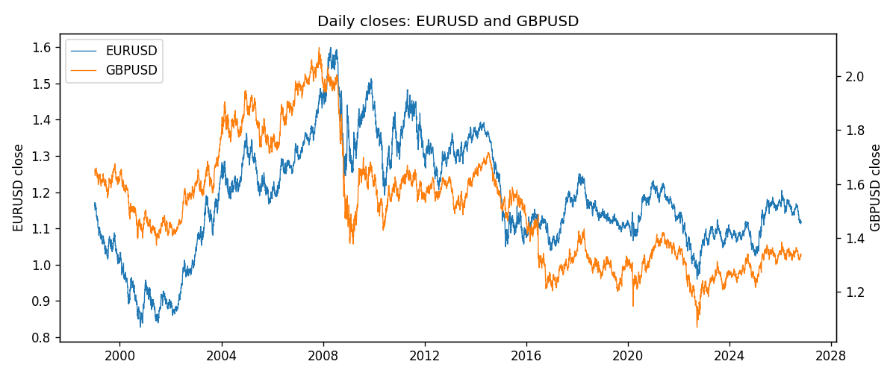
Daily log returns
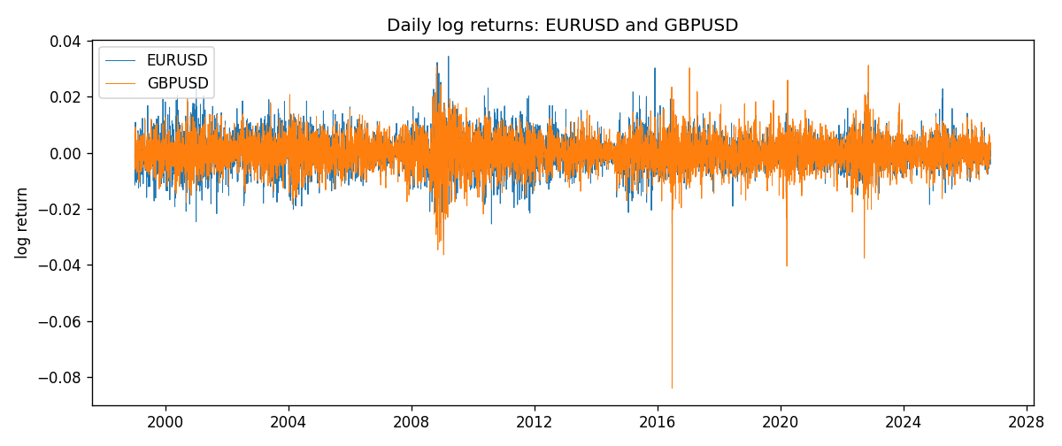
Log-return scatter
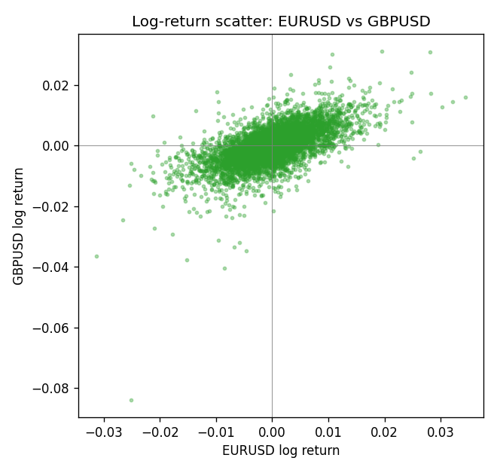

Data report
Every panel row for this pair slice is stored in the sibling Excel workbook named EURUSD-GBPUSD_Shrinkage_D1.xlsx. Full-panel covariance and correlation matrices are saved once under outputs/ as CSV files. Embedding all rows as a Word table is impractical at this length; the Word file holds the column list, column summaries, and the first and last 15 matched rows.
Columns: time, EURUSD_open, EURUSD_high, EURUSD_low, EURUSD_close, EURUSD_tick_volume, EURUSD_spread, EURUSD_real_volume, EURUSD_log_return, GBPUSD_open, GBPUSD_high, GBPUSD_low, GBPUSD_close, GBPUSD_tick_volume, GBPUSD_spread, GBPUSD_real_volume, GBPUSD_log_return
Column summaries (panel rows)
column | count | mean | std | min | 25% | 50% | 75% | max
EURUSD_open | 7127 | 1.1819407 | 0.15065555 | 0.8272 | 1.086455 | 1.16615 | 1.294285 | 1.5995
EURUSD_high | 7127 | 1.1870746 | 0.15125674 | 0.8326 | 1.09055 | 1.17128 | 1.29974 | 1.6038
EURUSD_low | 7127 | 1.1769341 | 0.14996546 | 0.8227 | 1.082375 | 1.16257 | 1.288915 | 1.5865
EURUSD_close | 7127 | 1.1819858 | 0.15061943 | 0.8267 | 1.08652 | 1.16617 | 1.294345 | 1.5997
EURUSD_tick_volume | 7127 | 103994.86 | 174033.72 | 469 | 9542.5 | 53148 | 99923.5 | 1471626
EURUSD_spread | 7127 | 19.176652 | 16.472988 | 0 | 8 | 12 | 20 | 50
EURUSD_real_volume | 7127 | 4.0656436e+10 | 1.6756658e+11 | 0 | 0 | 0 | 0 | 3.6149665e+12
EURUSD_log_return | 7127 | -3.8e-07 | 0.00580028 | -0.03123819 | -0.00324243 | 8.31e-06 | 0.00325629 | 0.03433183
GBPUSD_open | 7127 | 1.5143204 | 0.21800183 | 1.06854 | 1.323655 | 1.5093 | 1.62967 | 2.1066
GBPUSD_high | 7127 | 1.5206136 | 0.21856742 | 1.08366 | 1.32882 | 1.5159 | 1.636975 | 2.1161
GBPUSD_low | 7127 | 1.508003 | 0.21722806 | 1.03518 | 1.3185 | 1.501 | 1.623 | 2.0983
GBPUSD_close | 7127 | 1.5143843 | 0.21795834 | 1.06879 | 1.32373 | 1.5095 | 1.62965 | 2.1065
GBPUSD_tick_volume | 7127 | 95725.777 | 154086.85 | 62 | 10131.5 | 53562 | 92170 | 1273370
GBPUSD_spread | 7127 | 26.790936 | 19.185969 | 0 | 10 | 20 | 50 | 50
GBPUSD_real_volume | 7127 | 3.5930129e+09 | 8.4874724e+10 | 0 | 0 | 0 | 0 | 2.4038164e+12
GBPUSD_log_return | 7127 | -2.548e-05 | 0.00564718 | -0.08388241 | -0.00312586 | 3.034e-05 | 0.00318105 | 0.03112653
First 15 panel rows (selected columns)
time | EURUSD_close | GBPUSD_close | EURUSD_log_return | GBPUSD_log_return
1999-01-06 | 1.1623 | 1.6537 | -0.011547966 | -0.00060452184
1999-01-07 | 1.1712 | 1.6502 | 0.0076280636 | -0.002118709
1999-01-08 | 1.1585 | 1.6405 | -0.010902799 | -0.0058954193
1999-01-11 | 1.1503 | 1.6312 | -0.007103287 | -0.0056851331
1999-01-12 | 1.1555 | 1.6349 | 0.0045103728 | 0.0022657001
1999-01-13 | 1.1681 | 1.6499 | 0.010845346 | 0.0091330396
1999-01-14 | 1.1681 | 1.6531 | 0 | 0.0019376331
1999-01-15 | 1.1563 | 1.6502 | -0.010153245 | -0.0017558204
1999-01-18 | 1.1605 | 1.6522 | 0.0036256946 | 0.0012112405
1999-01-19 | 1.1603 | 1.6553 | -0.00017235436 | 0.0018745281
1999-01-20 | 1.1566 | 1.6472 | -0.0031939256 | -0.0049053846
1999-01-21 | 1.1601 | 1.6524 | 0.0030215416 | 0.0031518998
1999-01-22 | 1.1587 | 1.6565 | -0.0012075213 | 0.0024781662
1999-01-25 | 1.1552 | 1.6585 | -0.0030251979 | 0.0012066366
1999-01-26 | 1.1562 | 1.6597 | 0.00086527651 | 0.00072328374
Last 15 panel rows (selected columns)
time | EURUSD_close | GBPUSD_close | EURUSD_log_return | GBPUSD_log_return
2026-10-13 | 1.11965 | 1.32534 | 0.0037402957 | 0.0036434319
2026-10-14 | 1.11545 | 1.31884 | -0.0037582255 | -0.0049164679
2026-10-15 | 1.12172 | 1.32757 | 0.0056053107 | 0.0065976411
2026-10-16 | 1.12371 | 1.33257 | 0.0017724895 | 0.0037592051
2026-10-19 | 1.12086 | 1.33024 | -0.0025394633 | -0.0017500314
2026-10-20 | 1.12354 | 1.3377 | 0.0023881672 | 0.0055923442
2026-10-21 | 1.12318 | 1.33937 | -0.00032046717 | 0.0012476328
2026-10-22 | 1.12139 | 1.33967 | -0.0015949606 | 0.00022396082
2026-10-23 | 1.11989 | 1.33684 | -0.001338521 | -0.0021146949
2026-10-26 | 1.11735 | 1.33359 | -0.0022706559 | -0.0024340661
2026-10-27 | 1.11272 | 1.33044 | -0.004152342 | -0.0023648393
2026-10-28 | 1.1152 | 1.33254 | 0.0022262927 | 0.0015771808
2026-10-29 | 1.11772 | 1.33733 | 0.0022571351 | 0.0035881935
2026-10-30 | 1.11644 | 1.33913 | -0.0011458446 | 0.0013450605
2026-11-02 | 1.11881 | 1.3406 | 0.002120569 | 0.0010971256

